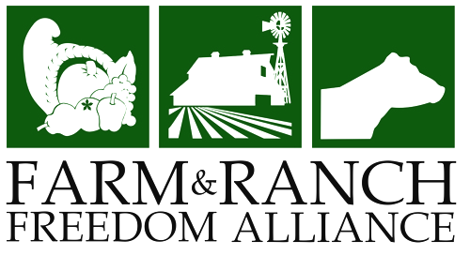
CITIZEN ACTIVISM WORKSHOP

November 10-11, 2014 | Barr Mansion
10463 Sprinkle Road, Austin, TX 78754

- Do you care about what’s happening with our food system, but you’re not sure where to start?
- Ever wondered which elected official you needed to call to take action on an issue or what to say to the person on the other end of the phone line when you do call?
- Already done some activism work and want to learn more about how to be really effective and make a significant impact?
If any of these describe you, then check out the Farm and Ranch Freedom Alliance’s two-day intensive training on how to be an effective citizen activist!

Our system only works when people become involved. And every person counts. FARFA regularly lobbies at both the state and federal level, and an essential part of our mission is providing educational resources for people affected by government farm and food policies, empowering them to speak up on behalf of themselves.
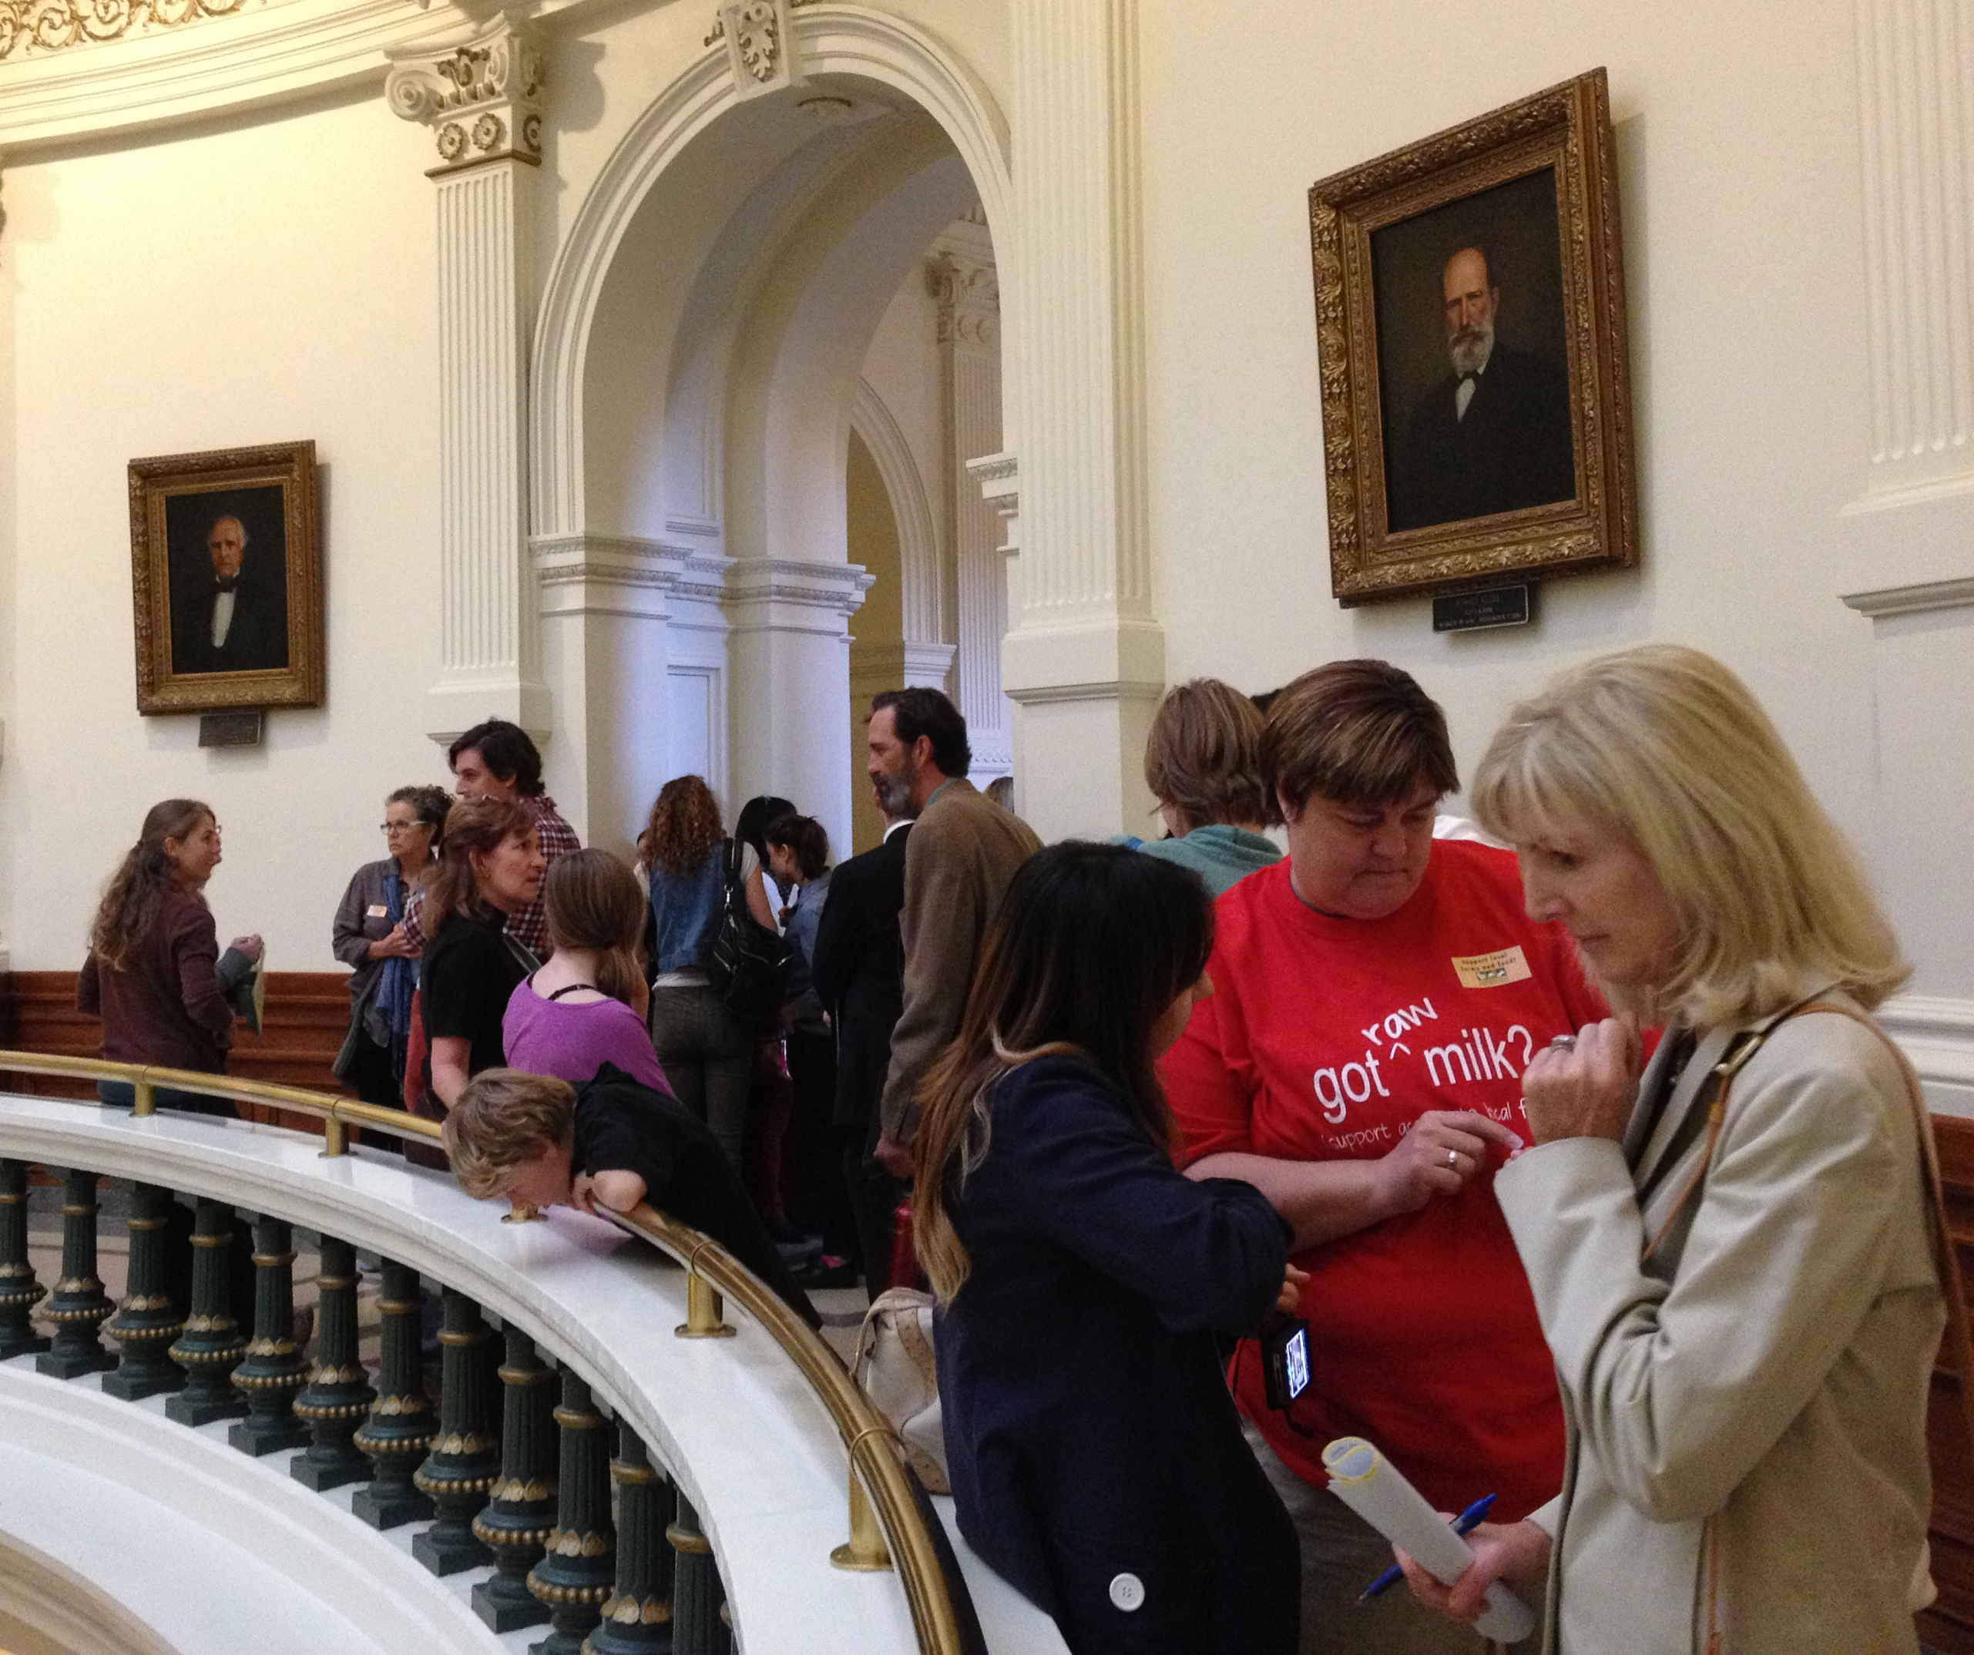
WORKSHOP AGENDA

Day 1:
- Developing your goals
- Finding allies and creating coalitions
- Creating and promoting your message

Day 2:
- Identifying the right people at various levels (city council, state legislators, or Congressmen)
- Meeting with your elected officials
- Developing effective tools and strategies

Seating is limited for this workshop so that we can provide personalized attention to all attendees. We want to ensure everyone gets the maximum benefit from the experience and that the workshop meets their goals for their activism work.

REGISTRATION: $40 for both days, including lunches.

Register online at www.FarmAndRanchFreedom.org/2014-citizen-activism-workshop
or fill out the registration form on the back.

Scholarships are available. For more information, contact Judith@FarmAndRanchFreedom.org or call 254-697-2661.
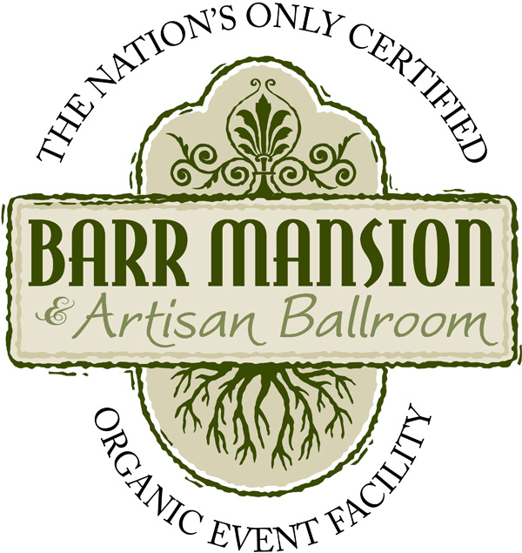
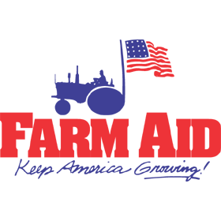
Sponsored by:

Farm & Ranch Freedom Alliance Activism Workshop
November 10-11, 2014 | Austin, Texas

Full Name:
Organization (optional):
Address:
City/State/Zip:
Email:
Phone:
Special Interests:

2-Day Registration Fee - $40

Both days include a lunch of organic foods prepared by Barr Mansion.

(1) Enclose a check to “Farm and Ranch Freedom Alliance” and mail to:
Farm and Ranch Freedom Alliance, P.O. Box 809, Cameron, TX 76520

(2) Or email the form to Judith@FarmAndRanchFreedom.org and pay online at www.FarmAndRanchFreedom.org/ 2014-citizen-activism-workshop

If you have any questions about the workshop, please call (254) 697-2661.

Please indicate any special needs or instructions below:

